SIMATS ENGINEERING
ASSESSMENT TOOL 1-Pseudocode Writing Task

COURSE NAME: R PROGRAMMING COURSE CODE: ITA04

COURSE OUTCOME COVERED

CO: Apply R programming fundamentals including data structures, vectors, matrices, arrays, and class types to perform mathematical operations and manage data effectively.
(Bloom Level -BL2- BL4)

Assessment Tool Weightage: 20%

QUESTIONS: Total Marks: 100

1. Variables and Data Types Analysis (BL4 – Analyze)
Design pseudocode to simulate basic variable handling in R programming:
- Declare variables of different data types (numeric, character, logical)
- Perform arithmetic and logical operations
- Display the results

Answer:
BEGIN
// Step 1: Declare and initialize variables of different data types
DECLARE numVar AS NUMERIC = 45.5
DECLARE charVar AS CHARACTER = "SIMATS Engineering"
DECLARE logVar1 AS LOGICAL = TRUE
DECLARE logVar2 AS LOGICAL = FALSE

// Step 2: Perform arithmetic operations
DECLARE arithmeticSum AS NUMERIC = numVar + 14.5
DECLARE arithmeticProd AS NUMERIC = numVar * 2

// Step 3: Perform logical operations
DECLARE logicalAND AS LOGICAL = logVar1 AND logVar2
DECLARE logicalOR AS LOGICAL = logVar1 OR logVar2
DECLARE logicalNOT AS LOGICAL = NOT logVar1

// Step 4: Display the results
PRINT "--- Variables and Data Types ---"
PRINT "Numeric Variable: ", numVar
PRINT "Character Variable: ", charVar
PRINT "Logical Variable 1: ", logVar1
PRINT "Arithmetic Sum (numVar + 14.5): ", arithmeticSum
PRINT "Arithmetic Product (numVar * 2): ", arithmeticProd
PRINT "Logical AND Operation: ", logicalAND
PRINT "Logical OR Operation: ", logicalOR
PRINT "Logical NOT Operation: ", logicalNOT
END

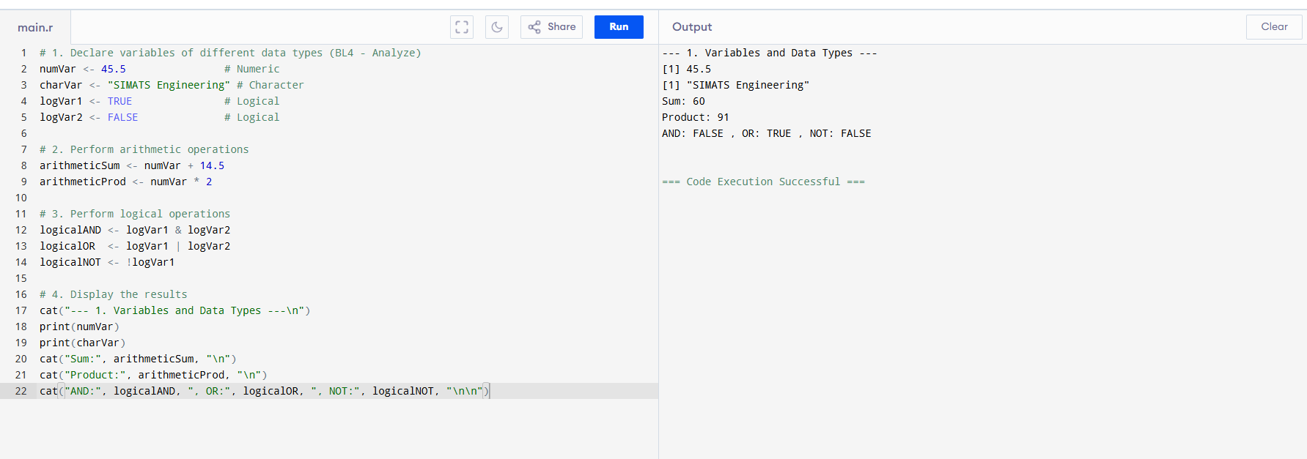

2. Data Structures Implementation (BL4 – Analyze)
Write pseudocode to demonstrate advanced data structures in R:
- Create and initialize a vector, list, and matrix
- Perform operations such as indexing, updating, and aggregation
- Compare the structures based on usage

Answer
BEGIN
// Step 1: Create and initialize a vector, list, and matrix
DECLARE myVector AS VECTOR = [10, 20, 30, 40, 50]
DECLARE myList AS LIST = List(ID = 101, Name = "Pradeep", Scores = [90, 85, 88])
DECLARE myMatrix AS MATRIX = Matrix(Rows = 2, Cols = 3, Data = [1, 2, 3, 4, 5, 6])

// Step 2: Vector Operations (Indexing, Updating, Aggregation)
DECLARE vecElement AS NUMERIC = myVector[3] // Indexing (30)
myVector[2] = 25 // Updating
DECLARE vecSum AS NUMERIC = SUM(myVector) // Aggregation

// Step 3: List Operations (Indexing, Updating)
DECLARE listName AS CHARACTER = myList$Name // Indexing named element
myList$ID = 102 // Updating

// Step 4: Matrix Operations (Indexing, Updating)
DECLARE matElement AS NUMERIC = myMatrix[2, 3] // Indexing Row 2, Col 3 (6)
myMatrix[1, 2] = 9 // Updating Row 1, Col 2

// Step 5: Display Results
PRINT "Updated Vector: ", myVector
PRINT "Vector Sum: ", vecSum
PRINT "Accessed List Name: ", listName
PRINT "Updated Matrix Row 1, Col 2: ", myMatrix[1, 2]
END
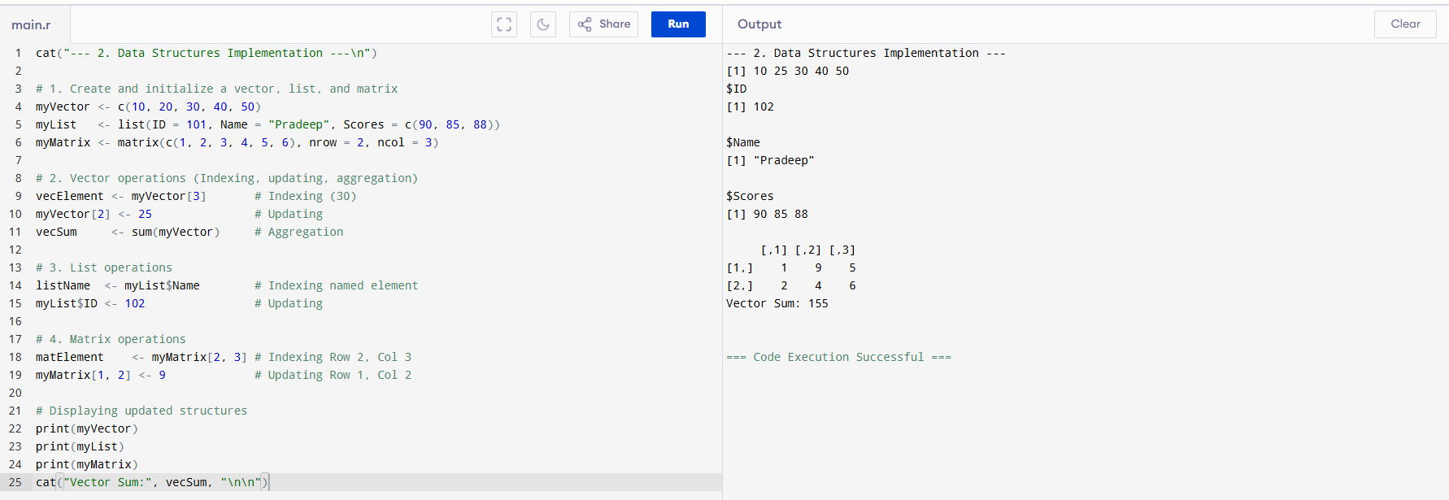

3. Matrix and Array Operations (BL4 – Analyze)
Design pseudocode to perform operations on matrices and arrays:
- Create a matrix and a 3D array
- Perform addition, multiplication (matrix), and element-wise operations
- Display the results and analyze differences

ANSWER:

BEGIN
// Step 1: Create a matrix and a 3D array
DECLARE matA AS MATRIX = Matrix(Rows = 2, Cols = 2, Data = [1, 2, 3, 4])
DECLARE matB AS MATRIX = Matrix(Rows = 2, Cols = 2, Data = [5, 6, 7, 8])
DECLARE array3D AS ARRAY = Array(Dim = [2, 2, 2], Data = [1..8]) // 2 Rows, 2 Cols, 2 Layers

// Step 2: Matrix Arithmetic Operations
DECLARE matAddition AS MATRIX = matA + matB // Element-wise addition
DECLARE matElementWiseMult AS MATRIX = matA * matB // Element-wise multiplication
DECLARE matTrueProduct AS MATRIX = matA %*% matB // Standard Matrix Multiplication

// Step 3: 3D Array Element-wise Operation
DECLARE arrayScale AS ARRAY = array3D * 2 // Multiply every element by 2

// Step 4: Display the results
PRINT "Matrix Addition Result: ", matAddition
PRINT "Matrix Element-wise Multiplication: ", matElementWiseMult
PRINT "True Matrix Product (%*%): ", matTrueProduct
PRINT "Scaled 3D Array (Layer 1): ", arrayScale[,,1]
END
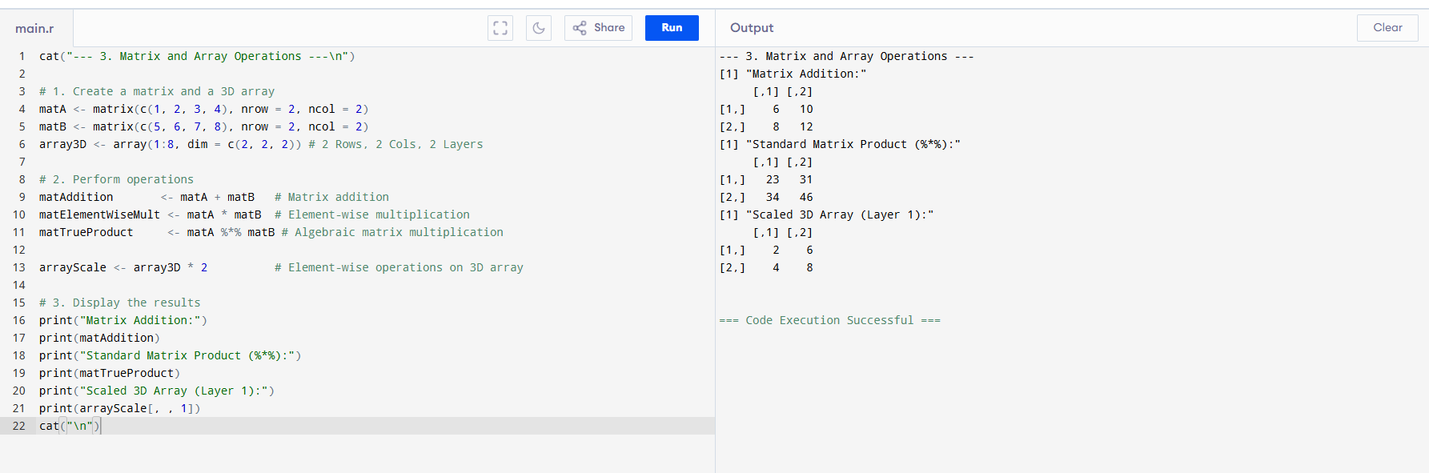

4. Data Frame Construction and Manipulation (BL4 – Analyze))
A dataset needs to be organized efficiently.
Write pseudocode to:
- Create a data frame with multiple columns (numeric and character)
- Add, delete, and modify columns
- Perform basic summary operations

ANSWER
BEGIN
// Step 1: Create a data frame with multiple columns (numeric and character)
DECLARE empDF AS DATAFRAME = DataFrame(
EmpID = [1, 2, 3],
EmpName = ["Alice", "Bob", "Charlie"],
Salary = [50000, 60000, 55000]
)

// Step 2: Add a column
empDF$Department = ["HR", "IT", "Finance"]

// Step 3: Modify a column (Give 10% raise to Salary column)
FOR i FROM 1 TO LENGTH(empDF$Salary) DO
empDF$Salary[i] = empDF$Salary[i] * 1.10
END FOR

// Step 4: Delete a column (Drop Department)
empDF$Department = NULL

// Step 5: Perform basic summary operations
DECLARE meanSalary AS NUMERIC = MEAN(empDF$Salary)
DECLARE maxSalary AS NUMERIC = MAX(empDF$Salary)

// Step 6: Display data frame metadata and statistics
PRINT "Manipulated Data Frame Structures: ", empDF
PRINT "Mean Employee Salary: ", meanSalary
PRINT "Maximum Employee Salary: ", maxSalary
END
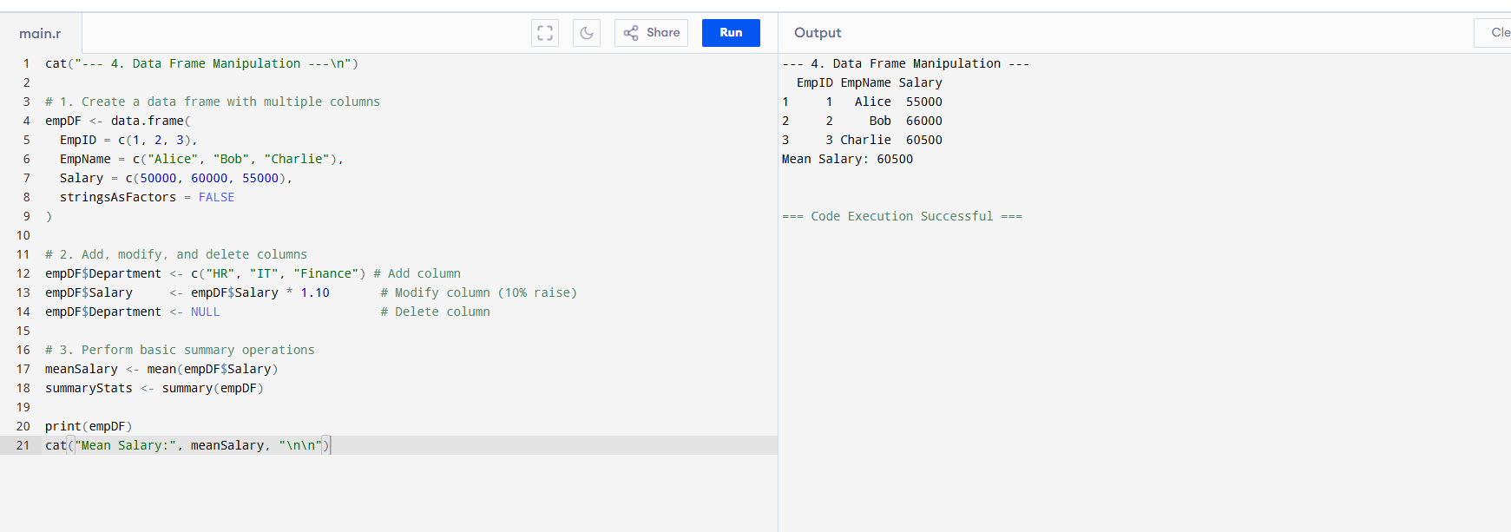

5. Functions and Logical Operations (BL4 – Analyze)
Design pseudocode to implement functions and logical vector operations:
- Create a user-defined function with input parameters
- Perform operations on logical vectors
- Return and display computed results

ANSWER:

// Step 1: Create a user-defined function with input parameters
FUNCTION filterAndCalculateMean(numericVector, logicalVector)
BEGIN
DECLARE filteredVector AS VECTOR = []

// Match indexes where logical vector evaluations are true
FOR i FROM 1 TO LENGTH(numericVector) DO
IF logicalVector[i] == TRUE THEN
APPEND numericVector[i] TO filteredVector
END IF
END FOR

// Calculate and return result
IF LENGTH(filteredVector) == 0 THEN
RETURN 0
ELSE
DECLARE meanValue AS NUMERIC = SUM(filteredVector) / LENGTH(filteredVector)
RETURN meanValue
END IF
END
ENDFUNCTION

BEGIN
// Step 2: Initialize test datasets
DECLARE dataVec AS VECTOR = [15, 24, 32, 48, 50]
DECLARE conditionVec AS VECTOR = [TRUE, FALSE, TRUE, TRUE, FALSE] // Logical vector

// Step 3: Call the function and pass the parameters
DECLARE computationalResult AS NUMERIC = filterAndCalculateMean(dataVec, conditionVec)

// Step 4: Display computed results
PRINT "Target Data Vector: ", dataVec
PRINT "Logical Condition Vector: ", conditionVec
PRINT "Computed Mean of Filtered Elements: ", computationalResult
END
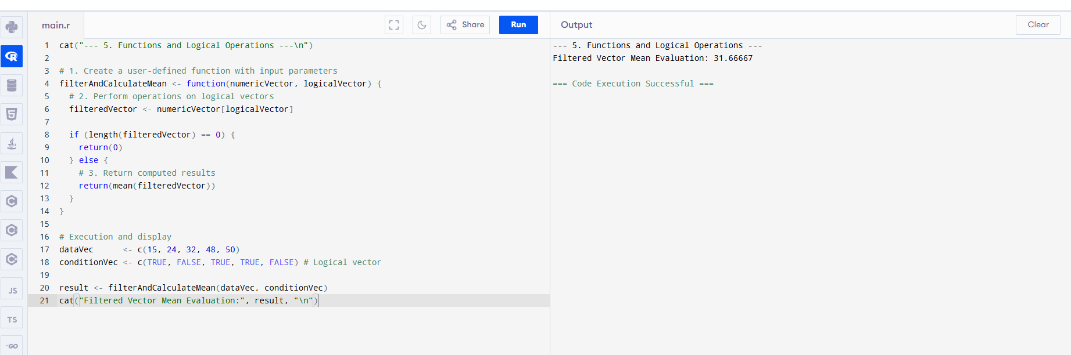

Code of Conduct:

I __pradeepkumar.S_________________ (Name / Reg No) certify that this submission is my original work and that I have adhered to the guidelines specified for this assessment.
I understand that any violation of academic integrity rules will result in disciplinary action.

Signature of the student:

Criteria | Weightage | Level 4 – Exemplary | Level 3 – Proficient | Level 2 – Developing | Level 1 – Beginning
Problem Understanding | 20% | Identifies all inputs, outputs, constraints accurately | Minor missing elements | Partial understanding | Incorrect interpretation
Algorithm Design | 30% | Complete, correct, and logically sound solution | Minor logical gaps | Partially correct logic | Incorrect approach
Use of Control Structures | 20% | Efficient and appropriate use of loops, conditions, functions/modules | Minor inefficiencies | Limited or basic usage | Incorrect or missing constructs
Pseudocode Structure | 10% | Well-structured, clear, consistent format, easy to follow | Mostly clear with minor issues | Difficult to follow in parts | Poorly structured and unclear
Completeness | 20% | Handles all cases; optimized approach | Handles most cases; reasonable efficiency | Handles basic cases only | Incomplete or inefficient

